**Semester: V Name of Student:**

**Academic Year: 2022-23 Student ID:**

**Class / Branch: TE IT**

**Subject: Advanced Devops Lab (ADL)**

**Name of Instructor:Prof. Manasi Choche**

**EXPERIMENT NO. 10**

**Aim: To perform Port, Service monitoring, Linux server monitoring using Nagios.**

## Step 1 – Configure NRPE on Linux Host

Follow the below steps to install and configure NRPE on the client machine and check connectivity with Nagios server.

### Step 1.1 – Install NRPE

vishal@apsit:~$ sudo apt-get install nagios-nrpe-server nagios-plugins

### Step 1.2 – Configure NRPE

After successfully installing NRPE service, Edit nrpe configuration file /etc/nagios/nrpe.cfg in your favorite editor and add your nagios service ip in allowed hosts.

vishal@apsit:~$ sudo nano /etc/nagios/nrpe.cfg

allowed_hosts=127.0.0.1, 192.168.64.3, 192.168.1.100

Where **192.168.1.100** is your Nagios server ip address.

After making above changes in nrpe configuration file, Lets restart NRPE service as per your system

vishal@apsit:~$ sudo /etc/init.d/nagios-nrpe-server restart

### Step 1.3 – Verify Connectivity from Nagios

Now run the below command from Nagios server to make sure your nagios is able to connect nrpe client on remote Linux system. Here **192.168.64.3** is your remote Linux system ip.

vishal@apsit:~$ /usr/local/nagios/libexec/check_nrpe -H 192.168.64.3

NRPE v2.15

## Step 2 – Add Linux Host in Nagios

First create a configuration file using below values. for example you Linux hosts ip is . We also need to define a service with host. So add a ping check service, which will continuously check that host is up or not.

vishal@apsit:~$ sudo nano /usr/local/nagios/etc/servers/MyLinuxHost001.cfg

define host {

use linux-server

host_name Linux_Host_001

alias Linux Host 001

address 192.168.64.3

register 1

}

define service{

host_name Linux_Host_001

service_description PING

check_command check_ping!100.0,20%!500.0,60%

max_check_attempts 2

check_interval 2

retry_interval 2

check_period 24x7

check_freshness 1

contact_groups admins

notification_interval 2

notification_period 24x7

notifications_enabled 1

register 1

}

Now verify configuration files using following command. If there are no errors found in configuration, restart nagios service.

vishal@apsit:~$ sudo nagios -v /usr/local/nagios/etc/nagios.cfg

vishal@apsit:~$ sudo service nagios restart

## Step 3 – Check Host in Nagios Web Interface

Open your Nagios web interface and check for new Linux hosts added in Nagios core service.

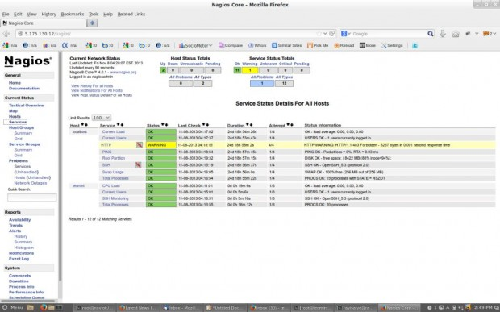



**Conclusion: Write your own findings.**